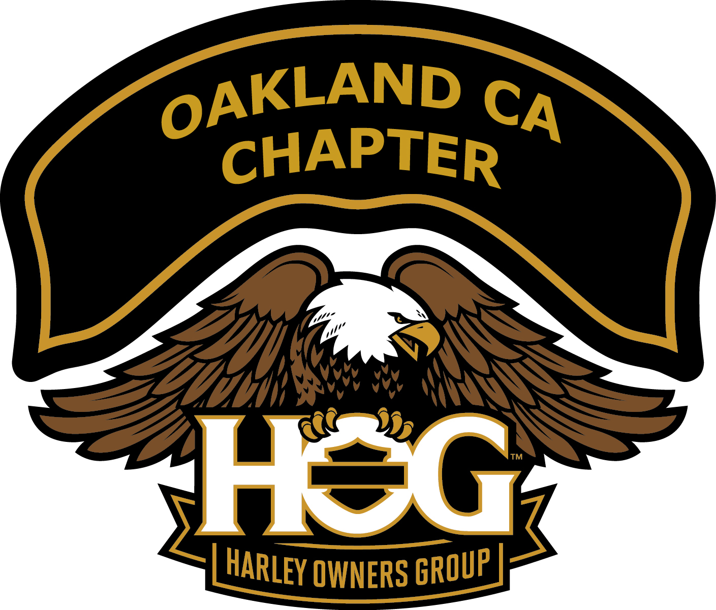

Welcome to the Oakland, CA Harley Owners Group (HOG). Members of Oakland
HOG have at least one common interest -- Harley-Davidson motorcycles. Being a member means meeting new people, participating in rides, events and charitable efforts. Oakland HOG prides itself as being one of the most active Chapters in the Bay Area. Rides are generally planned for every Saturday and Sunday of each month.
History
Fremont HOG (as it was originally named, based out of Fremont) was established in April, 1989 and became an official organization on June 21, 1989. The first meeting was held on April 20, 1989 and chartered fifty-five (55) members. At the time, Cycle Center of Fremont/Harley-Davidson was located on Fremont Blvd., next to the Round Table Pizza where the chapter's first meeting was and still is being held today. Dennis Hall, former owner of the dealership, appointed Randy Morgan as Director and he served for the next five years. In 1995, the chapter, with Dennis Hall's blessings, embraced the election process for their primary officers.
The first issue of the original chapter newsletter, "Road-Hog Rag", was published in July, 1989. The newsletter's name has since been changed to "Hog Lines".
Fremont HOG held the first Halloween Run at a private picnic location in Niles Canyon on October 15, 1989. This annual event is fun and provides income for both the chapter and its charity programs.
In 1991, Fremont HOG introduced the 'ABC's-in-a-Day'. This program was derived from National H.O.G.'s "ABC's of Touring". For more about this unique event, go to "ABC's in a Day".
The Fremont HOG organization became a Not-for-Profit-Organization in 2001.
In the fall of 2011, our Fremont Dealership moved to Oakland, and the name of the chapter was voted a few months later to become Oakland, CA Chapter - Oakland Harley Owners Group.
Getting Started
You have already taken the first step to becoming an Oakland HOG member by picking up this brochure. If you have purchased a Harley-Davidson from Oakland Harley-Davidson you will automatically receive a 1-year membership to the National Harley Owners Group (HOG).

Make sure you are also a member of the National Harley Owners Group, sponsored by Harley-Davidson Motor Company. To learn more about joining, call National HOG at 1 800-CLUB-HOG. Oakland HOG Membership is required to participate in most Oakland HOG chapter events. You must be a member in good standing of the National Harley Owners Group (HOG) to apply for or renew chapter membership.

Now complete the Oakland Harley Owners Group application. You can get the application many ways:
1) At our sponsoring dealership, Oakland Harley-Davidson.
2) From the Chapter Secretary by attending one of our meetings.
3) Visit our website at www.oaklandhog.org and go to Documents and click Membership Application.
You may turn in your application and pay your membership fee to the Chapter Secretary. Current dues are $25/year.

YOU’RE A MEMBER NOW!

Attend a Meeting
Chapter meetings are held on the 1st Thursday of each month at Oakland Harley-Davidson at 151 Hegenberger Road Oakland Ca. starting at 7:00pm., and the 3rd Thursday of each month at Round Table Pizza, 37480 Fremont Blvd., in Fremont starting at 7:30pm. It is a good idea to attend a meeting before your first group ride. This is a great opportunity to meet and get to know some of your fellow members. Not only is there a lot of great information at each meeting about upcoming rides, activities, and updates, but it’s a great way to meet your fellow HOG members and visit a little. Most arrive between 6:00 and 7:00 to get some food and visit prior to the start of the meeting. Once a quarter we have a HOG Member Orientation and Ride meeting. To find out more information about Oakland HOG plan on attending the next orientation meeting.

Be a proud member! We are proud to be known as the “Most Active Riding” HOG chapter.
We will encourage you to purchase your HOG logo patches and your name rocker to wear on your riding gear. Purchase your logo patches in the Clothing Department at the Oakland Harley-Davidson Dealership and your name rocker from the Chapter Concierge.

Your First Chapter Meeting

Participation and mileage are rewarded.

1. Find the Secretary!! The Secretary will:
- Ask you to fill out a new member application
- Add your name to the email distribution of rides / events and newsletter.
- Ask you to complete a new membership questionnaire.

2. See the Assistant Director
They will give you a new member packet, which will include a name rocker order form, this Welcome Letter and our Group Riding Guidelines

3. See our Chapter Concierge to order your name rocker

2. Buy raffle tickets! Our “Ladies of Harley” officer will walk around with raffle tickets at each meeting. Buying raffle tickets gives you a chance to win great prizes.

Going on a Ride
The Chapter Moto is: Ride Safe and Have Fun

Get a Ride Calendar: You can go to www.Oaklandhog.org or get a current ride calendar at the chapter meetings (Remember: For the most up to date information about a ride, call the HOG Hot line at (510) 888-4557. This will always be the most updated resource regarding any ride changes. It’s good to call before each ride to make sure there are no last minute changes – especially when weather can be an issue).

Leave Points and Times on the Calendar: The times listed are the times we actually leave as a group. Always come with a full tank of fuel. Some rides may have stops 50-100 miles from our leave point. If you want to talk for a few minutes, get a cup of coffee, etc., come earlier. We pull out promptly at the times listed on the calendar! Your road captain will do a pre-ride review of the ride, about 5 minutes before the leave time, upon which you will then be informed as to the important details for the ride.

Hand Signals: Since safety is important to us, ask any member, the safety officer, or the Road Captains for the basic hand signals we use. You can get this information at the Chapter Meeting or before your first ride with the group (come a little early). Some of the signals we use are illustrated at the end of this document. Other familiar signals include:

- Raising your left arm and index finger signals single file.
- Raising your left arm and index finger and little finger signals staggered formation.
- Raising your left arm and index finger pointing toward your right indicates roadside hazard on right such as a bicyclist.

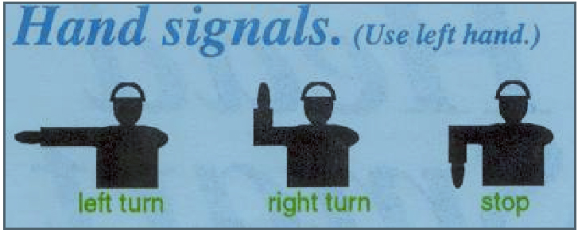

Foot Signals
Foot signals are often used to indicate road hazard on the right or left. This is done by removing your right or left foot front the footrest and pointing o the hazard with the appropriate foot.

General Ride Information: We ride to our destination as a group, but after we reach our destination everyone is free to return when they wish, and via the route they wish. If you want to ride with others, speak with them before the ride or when you arrive at the destination. It is always a good idea to have a map for Northern California with you at all times. You must notify the road captain if you are leaving the ride prior to its completion.

When the group ride is a staggered formation, we ride with a 2 second interval between the bike directly in front of you and a 1 second interval to the bike that is diagonally in front of you. When riding single file, we use ”the 2 second rule,” keeping 2 seconds between each bike. If we need to ride single file, the road captain will raise their arm up with their index finger up. We pass this down the line by each rider holding up the left index finger over their head. This is usually done on narrow or twisty roads. The following is an example of the “2 second rule:”

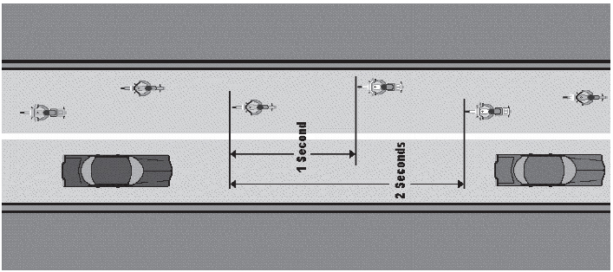

Signing Waivers: You need to sign a waiver (1 per rider) annually for new and returning active members. All active members must sign in at each ride / event! This will be used to account for you on the ride as well as earning you participation points and mileage toward awards. Guests must also sign a waiver form for each ride.

Run Start Locations: Our run start locations are convenient and accessible to food and gas:
- Oakland Harley-Davidson: 151 Hegenberger Road.
- Denny's Fremont: 5280 Mowry Ave. Cross Street Farwell.
- Chevron Livermore: 4707 First Street. Take First Street Exit off I-580.
- Alcosta Chevron San Ramon: 21320 San Ramon Valley Blvd. Take Alcosta Blvd. exit off Interstate-680 and go west to San Ramon Valley Blvd.
- Star Bucks - San Lorenzo: 15600 Hesperian Blvd. Cross street is Lewelling
- McDonalds Fremont Mission Blvd @ I-680: 42800 Mission Boulevard

*** Some runs may meet and leave from other locations. Listen to the HOG line
(510-888-4557) for leave times and location changes!!***

Information
We publish a monthly newsletter that is posted on our website and available at the Oakland Harley-Davidson Dealership. A calendar of events is included in the newsletter as well as on our website. Major events for the year are also listed at www.oaklandhog.org . Please check with an officer for the user name and password to access the web site. You must be a member in good standing to access the website. For ride and meeting information you should always call the Oakland Hog Line (510-888-4557) for the most current information.

Ride info is also emailed to members who have accepted the invitation to Oakland All-Members Yahoo Group.

2014 Elected Officers
Director: Dan “Droopy” Bustinduy director@oaklandhog.org
Assistant Director: Reed R. Bagnes asst_director@oaklandhog.org
Secretary: Angel Napitan secretary@oaklandhog.org
Activities Officer: Vacant activities_officer@oaklandhog.org
Treasurer: Glenn Martin treasurer@oaklandhog.org
Ladies of Harley Officer: Bunny Norris loh@oaklandhog.org

2014 Appointed Officers
Head Road Captain: Pappy Norris
Safety Officer: Bob Souza
Sergeant at Arms: Ron Meier
Chapter Photographer: Lito Rotor
Marathon Coordinator: Reed R. Bagnes
Hogspitality: Nance Souza
Concierge: Cindy Roarty
Webmaster: Marian Stevens
Newsletter Editor: Marian Stevens
Historian: Marian Stevens

